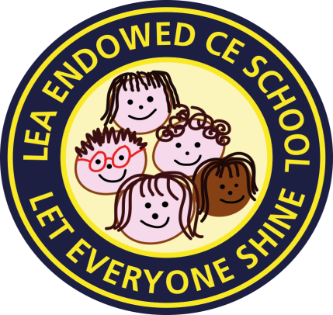

**Lea Endowed CE Primary School**

Newsletter No 13

Friday 26th April 2024

Our theme this half term is

**JOY**

**“Let your light shine.”** Matthew 5:16

It has been wonderful to see some sunshine over the last few days; the children were delighted to finally be able to play on the school field, for the first time in 2024! A big thank you to Miss Wilson and the Eco group for organising a super celebration of God’s wonderful world on Earth Day. The children took part in environment-based activities and the teachers gave out green heart stickers to those children who had shown they were showing special care of our environment and considering the impact we have on our precious planet. In more recent months, I have been increasingly aware of the pressures many families are facing, be it coping with mental health and wellbeing of family members, financial challenges or struggling with children with additional needs. As a school, we always want to do our best to support our families. I have set out below, a few suggestions of places you can access additional support. You’ll find more information on these services, on our school website, along with our offer of Early Help. Please don’t struggle on your own.

**POSITIVE MINDS**

Parent/Carer Support Group

For parents & carers who are supporting a child, whatever age, with Neurodiverse and Mental Health difficulties – this can be really challenging, isolating, emotionally, physically and mentally exhausting.

**YOU ARE NOT ALONE!**

[www.Lancashirepositiveminds.co.uk](http://www.lancashirepositiveminds.co.uk/)

Telephone– 07824 042908

Or see the flyer on our school website, under our Mental Health & Wellbeing tab.

**COMMUNITY DROP IN**

**Are you looking for some support and advice?**

**Tuesdays April 30th, May 28th, June 25th, July 30th 2-4pm**

**Drop-in sessions at the Ribbleton Family Hub where**

**you can call in and speak with a range of agencies, including, Preston City**

**Council, Citizens Advice, Lancashire County Council and Community**

**Gateway. Advice will be available on a range of subjects including:**

**Housing Debt Advice Food Banks**

**2yr Funded Nursery Places Training and Employment**

**Fire Safety And more…**

**Ribbleton Family Hub, Ribbleton Hall Drive, Ribbleton, Preston, PR2 6EE**

**BREAK TIME**

**Break Time** provides fun group activities for children and young people aged 4-18 with special educational needs and/or disabilities (SEND). Activities take place after school, at weekends and during school holiday periods.

See the flyer under our SEND tab on the school website.



**Mrs Seagrave’s Great Manners Award**

In the last two weeks, I have been delighted to present my special awards for excellent manners and a respectful attitude to:

**Henry in Year 3**

**&**

**Emily in Year 6**

Well done and keep shining brightly.

I am very proud of you both.

**ATTENDANCE Our school target is 96%**

**Winner of the Week**

|  |  |  |
| --- | --- | --- |
| **Class** | **9th-11th April** | **12th-18th April** |
| **1** | **83.91%** | **89.31%** |
| **2** | **95.98%** | **95.61%** |
| **3** | **92.22%** | **95.00%** |
| **4** | **89.25%** | **92.90%** |
| **5** | **95.83%** | **92.50%** |

**“Be on time, it helps you shine.”**

**Come** **to school, it’s really cool.”**

**Free School Meals and Pupil Premium**

If you get any of these [qualifying benefits](https://www.lancashire.gov.uk/children-education-families/schools/free-school-meals/?page=2), school can get extra funding, called pupil premium, if you [apply](https://www.lancashire.gov.uk/children-education-families/schools/free-school-meals/?page=3) with LCC.

This funding allows us to subsidise school trips, provide free milk and pay for trips and extra resources.

Thank you for your ongoing support.

Have a lovely weekend,

C M Seagrave